ARTBOX LONDON: GREAT ART TREASURE HUNT

TEAM NAME:
Museum of London: Lunch Space
Photography themes: “Reflections”, “Animals” and “Old and New”
Walk to the gardens in front of the Museum of London entrance.
Q1: What animal is in the mouth of Milo?

Q2: How many years did it take to rebuild the city after the Great Fire of London?
Q3: Where exactly did the Great Fire start?
Sketch 1: Find Christopher Le Brun’s ‘Union - Horse with Two Discs’. Take 5 minutes to sketch this using the paper provided (everyone in the team)
Head back towards the Lunch Space
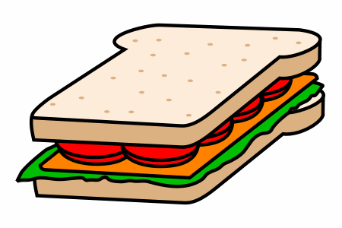
Q4: What activity did the Earl of Sandwich
like doing while eating sandwiches?
Find Nettleton Walk & John Wesley Highwalk - follow the signs for
Ironmongers’ Hall and go down to the gate
Photo 1: Take a photo of your group at the gates to Ironmongers’ Hall
Q5: How many lizards can you see above the gate? | 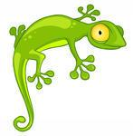
Get back on to the John Wesley Highwalk – at the end of John Wesley Highwalk, turn right and follow the sign to the Barbican Centre (Thomas More House will be to your left)
Q6: Before you get to Wallside, look around the square ,what musical instrument can you not
play there?
Walk along Wallside and look out for the watery graveyard.
Q7: How many graves can you spot?
At the end of Wallside, turn left onto The Postern. Look out for the steps to your left and walk down to St Giles Terrace.
Photo 2: Take an interesting photo in St Giles Terrace

Q8: What animal has wings in the stained glass of
the church?
Q9: How many Barbican Towers are there?
Go back up the stairs and continue your way along The Postern and bear
left onto Gilbert Bridge.
Photo 3: Take an interesting photo of the floating gardens
Keep walking along the bridge
Q10: Find SILVER cast in stone. Who fixed this here?
Sketch 2: Draw a quick sketch of that person on the paper provided.
Keep walking in the same direction with the Golden Faces on your left.
Follow the yellow line at your feet, turning right onto Speed highway.
Photo 4: take a photo of your favourite part of Dorothy Annan’s mural
Turn left and walk up the stairs of Speed Highwalk, walk straight ahead,
passing by the Barbican Conservatory to your left.
Photo 5: Take an interesting photo around Ben Johnson Place (Take an optional break here)
Keep right on Ben Johnson Place and find the green signs ‘access to street
level’. Walk down to Whitecross Street and continue on Whitecross Street. (Optional break: Opposite Waitrose you can walk through Shrewsbury Court and into the park)
Q11: “Eat, Speak, Find and Seek”. Where is the Hot Dog on Dufferin Street? (stay on Whitecross St)
Q12: Can you find a bear in the Sky? What is his name?
Q13: Which little creatures sit on fish, sausages, pies and steaks?
Turn left onto Garrett Street.
Q14: Which Superhero is hiding amongst the Olympic Heroes?
Keep walking and cross over a Lane of Gold to Baltic Street East. Turn right
when you get to TIMBER Street!
Photo 6: Look out for a napping fox. Take a photo next to him. BE CAREFUL OF THE ROAD!
Turn right at the top of Timber Street and walk along Old Street till you get to the traffic lights. Cross over the road and turn onto Central Street. Continue on Central Street until you see Central Street Café on your right (in St Luke’s Community Centre).
FINISHED

