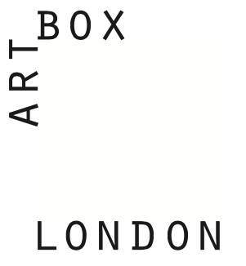

Supporter’s Personal Details, Gift Aid Declaration and Standing Order Mandate

Title: _________ First name or initials: ________________________________
Surname: _________________________________________________
Address: _________________________________________________
_________________________________________________
Post code: ___________
Telephone: _________________________________________
Email: _________________________________________

giftaid it

Yes, I am a UK taxpayer and would like Artbox London to treat my donations made today and in the future
as Gift Aid donations. I confirm that the amount of income tax and/or capital gains tax I pay is at least equal to all the tax that can be reclaimed as gift aid by the charities and community amateur sports clubs to which I donate. I understand that Artbox London will reclaim in tax as gift aid, 25p on every £1 that I give.

No, I am not a UK taxpayer.

Signature: _________________________________________ Date: ___/___/________

Please tell Artbox London if you want to cancel this declaration, if change your name or home address or if you no longer pay sufficient tax on your income and/or capital gains to cover the tax reclaimed on your donations. Please note that you may be able to reclaim a portion of higher rate income tax, if you pay it, on your gift aid donations. VAT and council tax are not part of the gift aid scheme.

Please keep me informed of Artbox London’s events and news via email.

Payment Instructions

To the manager of: _________________________________________________ Bank / Building Society
Address: _________________________________________________
_________________________________________Post code:___________
Name of the account: __________________________________________

Account number:
Sort code:

Please debit the above account and pay: Artbox London, Community Account, No: 02325527 Sort Code: 40-04-01

I wish to contribute the sum of: £________ per _________(eg: month, quarter, year)
The first payment to be on, Date: ___/___/________

Please quote reference: _________________________________________(to be completed by Artbox London)

Signature: _________________________________________ Date: ___/___/________

Please return this form to Artbox London 67 Gladstone House, 31 Dowells Street, London, SE10 9FF.

