How to find Artbox London, 1a Airdrie Close, London N1 0DT

- Look for the Coop on Caledonian Road (303-311 Caledonian Road)

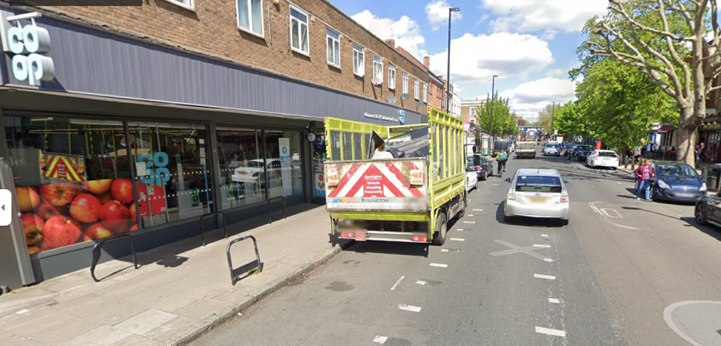

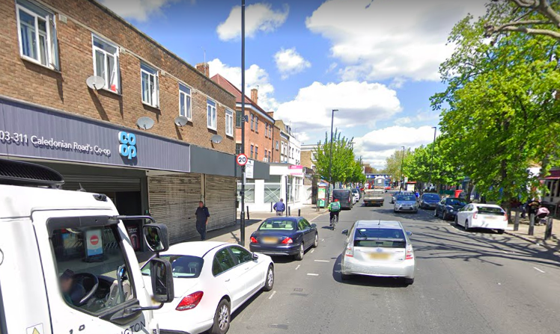

- Turn onto Kember Street:

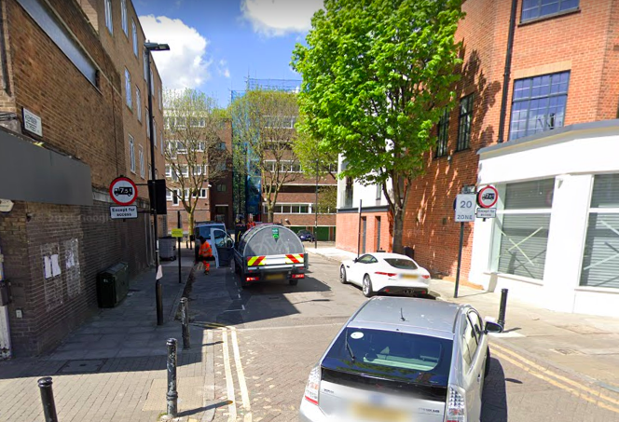

- At the end of Kember Street, turn left onto Carnoustie Drive:

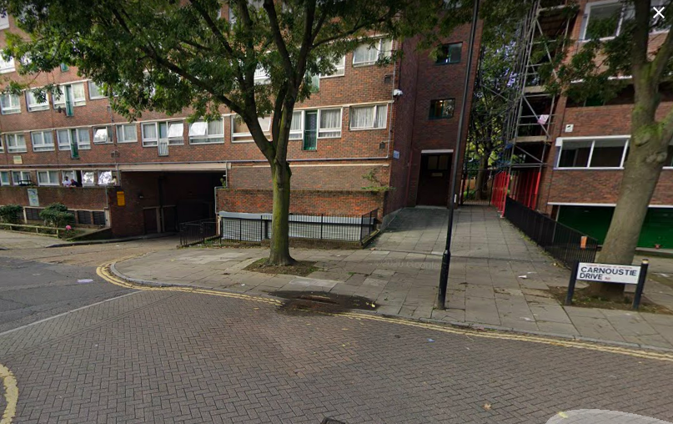

- Go down the ramp and Artbox is on your left:

