Artbox Summer Programme 2018

25th July – 11th August

Date | 10am - 5pm (one hour lunch break)
Wednesday  25th July | Drawing and Painting People | 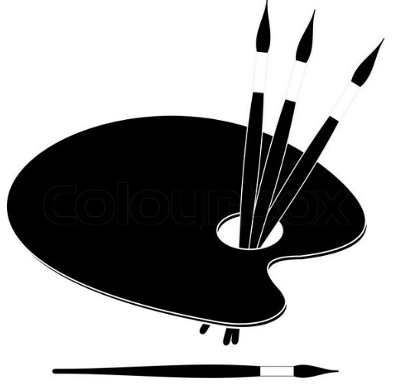
Thursday  26th July | Working with clay | 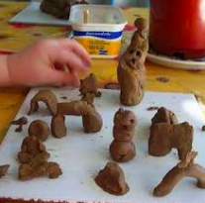
Friday  27th July | TRIP: Tower Bridge Engine Rooms | 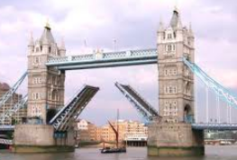
Saturday  28th July | Collage
Wednesday  1st August | Drawing and Painting Animals
Thursday  2nd August | Working with clay
Friday  3rd August | TRIP: Botanical drawing at the Culpeper Gardens | 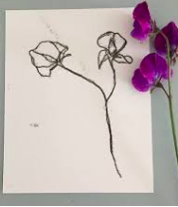
Saturday  4th August | Creating an abstract | 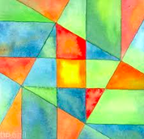
Wednesday  8th August | Printmaking
Thursday  9th August | Working with clay
Friday  10th August | Activity of your choice/complete work | ?
Saturday  11th August | TRIP: Art gallery with a picnic

